Tree of Life
Aye-Ayes
Lauren McCauley and Heather St.Clair
6/4/08

AYE- AYE
DAUBENTONIA MADAGASCARIENSIS

DESCRIPTION:
Classification of organism:
- Kingdom: Animalia
- Phylum: Chordata
- Class: Mammalia
- Order: Primates
- Suborder: Strepsirrhini
- Family: Daubentoniidae
- Genus: Daubentonia
- Species: Madagascariensis ^{[1]}
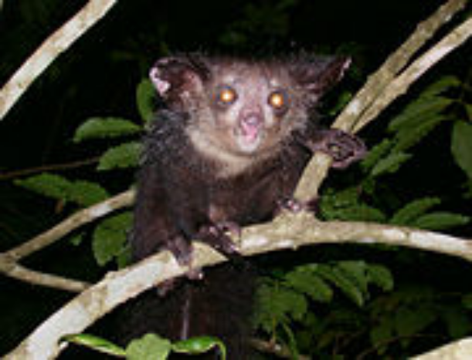

Physically, Aye-ayes are strange-looking creatures. They are small, nocturnal primates with coarse black or brown hair and an elongated middle finger. Aye-ayes are generally about sixteen inches in length, with an average weight of 5.5 – 6.5 pounds. The Aye-aye is the world’s largest nocturnal primate and features very large incisors that grow continually throughout its life, which assist the Aye-aye in gnawing through tree bark to expose grubs hiding beneath. It has very large eyes for nocturnal foraging, opposable thumbs, and a bony middle finger that can be up to three times longer than its other fingers. This frightening-looking appendage helps it pry bugs from the bark of trees. ^{[2]}
Aye-ayes, like lemurs, are found only on the island of Madagascar. ^{[3]} They live primarily in the canopies of the rainforest. They are usually solitary animals that forage in their own specific zones or territories that range from up to twenty acres for females to eighty for males. During the day, aye-ayes sleep in nests that they have built in the branches of trees. ^{[1]}
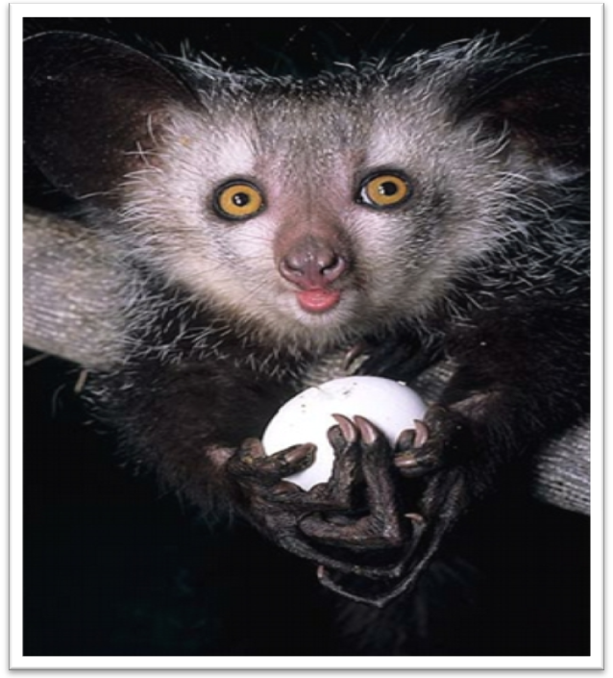
Aye-ayes fill the ecological niche of a woodpecker. They have large ears which assist them, through echolocation, in locating grubs hidden beneath tree bark. ^{[2]} Aye-ayes also use their bony, long middle fingers to tap along the trees, listening for hollow places where insects might be living. Then they gnaw through the bark and use those specialized fingers to scoop out their prey. ^{[3]} Aye-ayes are omnivores, and aside from grubs and insects, they also eat fruit, nuts, seeds, nectar, and fungi. Occasionally they steal eggs, sugar cane lichen, and other fruit from villages.^{[1]}

Juvenile Aye-aye Holding Egg
Daubentonia Madagascariensis
Photo by David Haring
Aye-ayes are an endangered species, due to habitat destruction and extermination by superstitious villagers. ^{[1]} Only about 2,500 live in the wild and a couple dozen in captivity. ^{[3, 1]} The Duke Lemur Center at Duke University holds the largest number of Aye-ayes, and in 2006, they successfully managed to produce the first aye-aye born in captivity to parents who had also been born in captivity. ^{[1, 2]} The lifespan of the Aye-aye is not known, but the record in captivity is twenty-three years. Infants stay with their mothers for about two years, though they are generally weaned after about seven months. Although fathers stay close until the infant has matured a bit and they occasionally share food, their primary social interaction is with their mothers. Young Aye-ayes are often very playful. They engage in play with their mothers and, after about three months, with other juveniles. Aye-ayes are mostly solitary, but sometimes they forage socially, and they do interact during mating. Aye-ayes are not monogamous, and females are dominant, causing males to become very aggressive during mating cycles. ^{[1]} Research conducted at the Duke University Primate Center has yielded a wealth of information regarding the mating practices of Aye-ayes and it has been determined that they are far more social than once thought. In the wild, when they begin their reproductive cycles, females call and present themselves, inviting males to begin competing for her attention. They need social interaction to mate, and apparently learn these mating practices in the wild, which is why it has taken so long for Aye-ayes in captivity to figure out how to mate. ^{[2]}

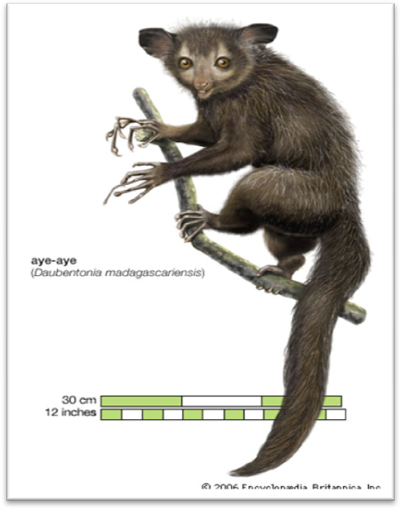
By Courtesy of Encyclopedia Britannica, Inc., Copyright 2006; used with permission
www.britannica.com

EVOLUTION:
The evolution of the Aye-aye began 60 million years ago when they split from the lemur family on the island of Madagascar. At some point in the past thousand years, the Daubentonia Robusta, became extinct, making the Aye-aye the only living member of the genus Daubentonia. Over time, they have adapted to fill the same ecological niche that the woodpecker occupies in other areas of the world, by developing anatomical characteristics which make them well-suited for this purpose. From their large eyes and ears, to their specialized fingers and teeth, Aye-ayes have adapted remarkably well to their environment and their niche. ^{[1]} Despite the Aye-ayes ability to overcome the many obstacles that have allowed them to successfully occupy such a unique niche, they still face the challenge of survival, as humans have become their biggest threat.

CHALLENGE ISSUE:
The native people of Madagascar have many superstitions regarding the Aye-aye. They believe that if an Aye-aye wanders into a village, someone in that village will die; that if an Aye-aye points it middle finger at a person then that person will die, unless they kill the Aye-aye first. Some believe that the Aye-aye is simply bad luck or an evil omen. These superstitions perpetrate the killing of this harmless animal. Ironically, they also prevent the killing of Aye-ayes for food. ^{[3]} Can you think of other species that are killed for reasons other than food?

ACKNOWLEDGEMENTS
We would like to thank the following individuals, organizations and websites for their contributions and copyright permissions:
- David Haring of Duke Lemur Center at Duke University – Juvenile Aye-aye Holding Egg Daubentonia Madagascariensis

- Encyclopedia Britannica – aye-aye (Daubentonia Madagascariensis) illustration

- Wikipedia

REFERENCES:
1. “Aye Aye.” Wikipedia. 5/21/2008. 5/25/2008.
http://en.wikipedia.org/wiki/Aye-aye#Classification
2. “Angelique the Aye Aye, a Primate Center Triumph.” Duke University Office of News & Communication. January 26, 2006. 5/22/2008.
http://news.duke.edu/2006/01/angelique.html
3. Jurmain, Robert, et al. “Ayes-Ayes: Victims of Derived Traits and Superstition.” Introduction to Physical Anthropology. 11th Ed. Belmont, CA: Thomson Wadsworth, 2008. 151.

