Flower Images Of Catharanthus roseus

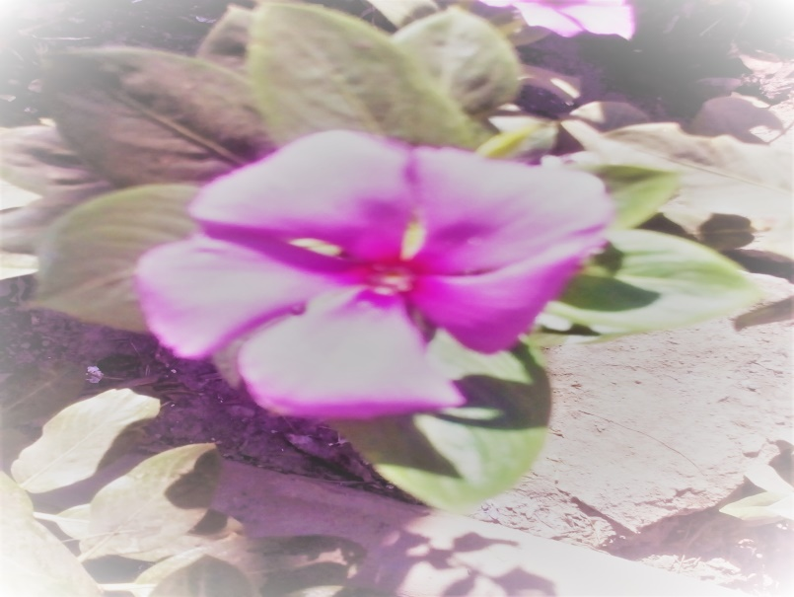
Kingdom: | Plantae
(unranked): | Angiosperms
(unranked): | Eudicots
(unranked): | Asterids
Order: | Gentianales
Family: | Apocynaceae
Genus: | Catharanthus
Species: | C. roseus

